Periodic Motion
An OS Creation by Shazin

Common Formulas:
y=distance of particle from
Equilibrium
A=Amplitude
ω=Angular Velocity or Angular
Frequency
T=Period
f=Frequency
δ=Initial phase

General Equation of Periodic Motion:
Properties of Periodic Motion:

***Note: When the object or particle is at the highest distance from equilibrium meaning when y = A , the velocity is 0. The velocity is maximum at equilibrium.

*** Note: The negative sign in acceleration implies that, the acceleration is always at the opposite direction in respect to the velocity of a periodic particle .
Acceleration is maximum at Amplitude and Minimum or 0 at equilibrium.

Force Constant (K):
Force Constant or K is the ratio of applied Force and displacement of an object from equilibrium due to the application of Force.
If , the applied force is F and displacement from equilibrium is x then,

Force constant can be applied in any sort of Classical Mechanical scenario . For example spring , object , particle etc.
Relations of K with different properties:

**Note : Thus formula or equation can be used in any periodic motion.

** Here m = Mass of the object or Particle

Phase of Periodic Motion:
The term Phase implies the angle of the particle in periodic motion.
Suppose the equation of a Simple Harmonic Motion (SHM) is
Here Phase is the angle of sine meaning Phase = (ωt + δ).
We can identify the position , velocity , direction from the phase. Let’s have a look at the pictures
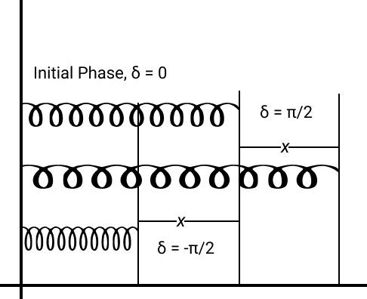
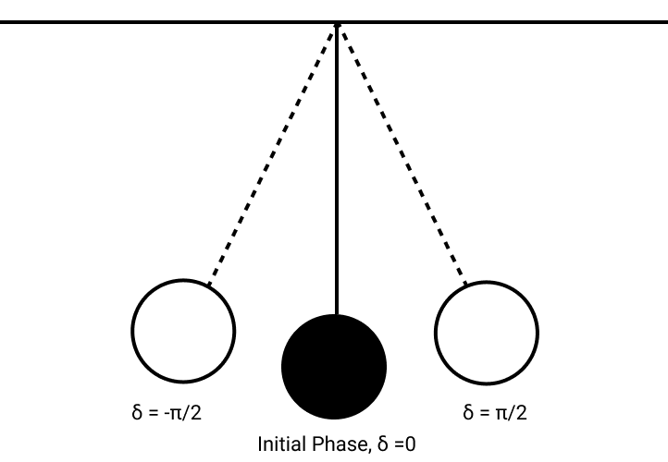
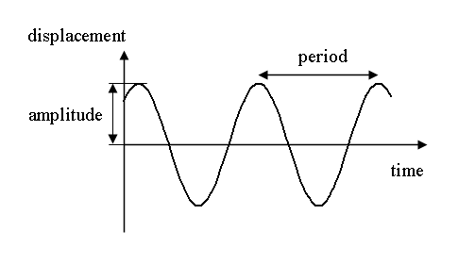
below:

At the first picture , a coil spring is shown in 3 phases. In First Phase the Spring is at
an equilibrium state. Let’s add a force and increase x unit of length. At this point if we leave the spring it will stretch and hence it’s length will be decreased by the same count of it’s increasing length which is x. If this event is happening in a vacuum where there is no distracting forces like friction or gravity , then the spring will keep increasing and stretching it’s length. So the highest length is it’s Amplitude. Now when the spring is at the highest or the lowest length it’s phase is +π/2 and – π/2. Now the δ in the equation is called the initial phase. So, if we start the motion from let’s say a phase of π/6 the δ will be π/6 . Now because the Phase will be the same after a certain Period (T) the graph of this motion will be a Sine wave (3rd Picture) . Same thing happens with the Pendulum in the 2nd Picture.

SHM of Pendulum:

Here, L = the actual Length of Pendulum’s string, and g is gravitational acceleration.

Energy in SHM:
Kinetic Energy:

Potential Energy:

Total Energy:

Combined Oscillation of Springs:
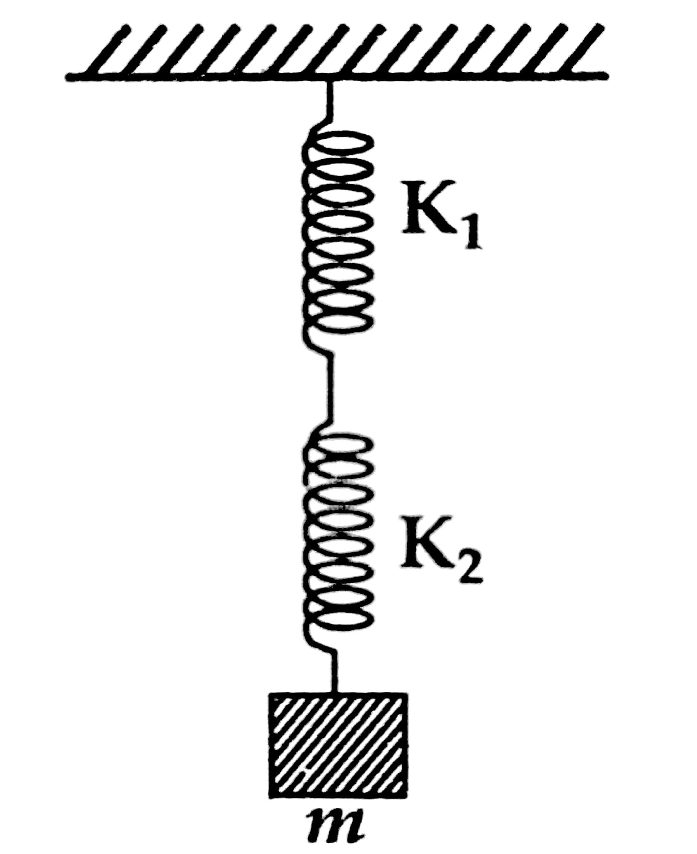
Series Combination:
Here is a visual interpretation of springs in a series combination
If the Force Constant of two springs in series combination is K_{s}

And the oscillation Period would be

**Tip to remember: If Two springs are connected in a way that, one spring
is connected to another spring’s end point or foot point and the mass is
connected to the last spring’s foot point this is a series combination.

Parallel Combination:
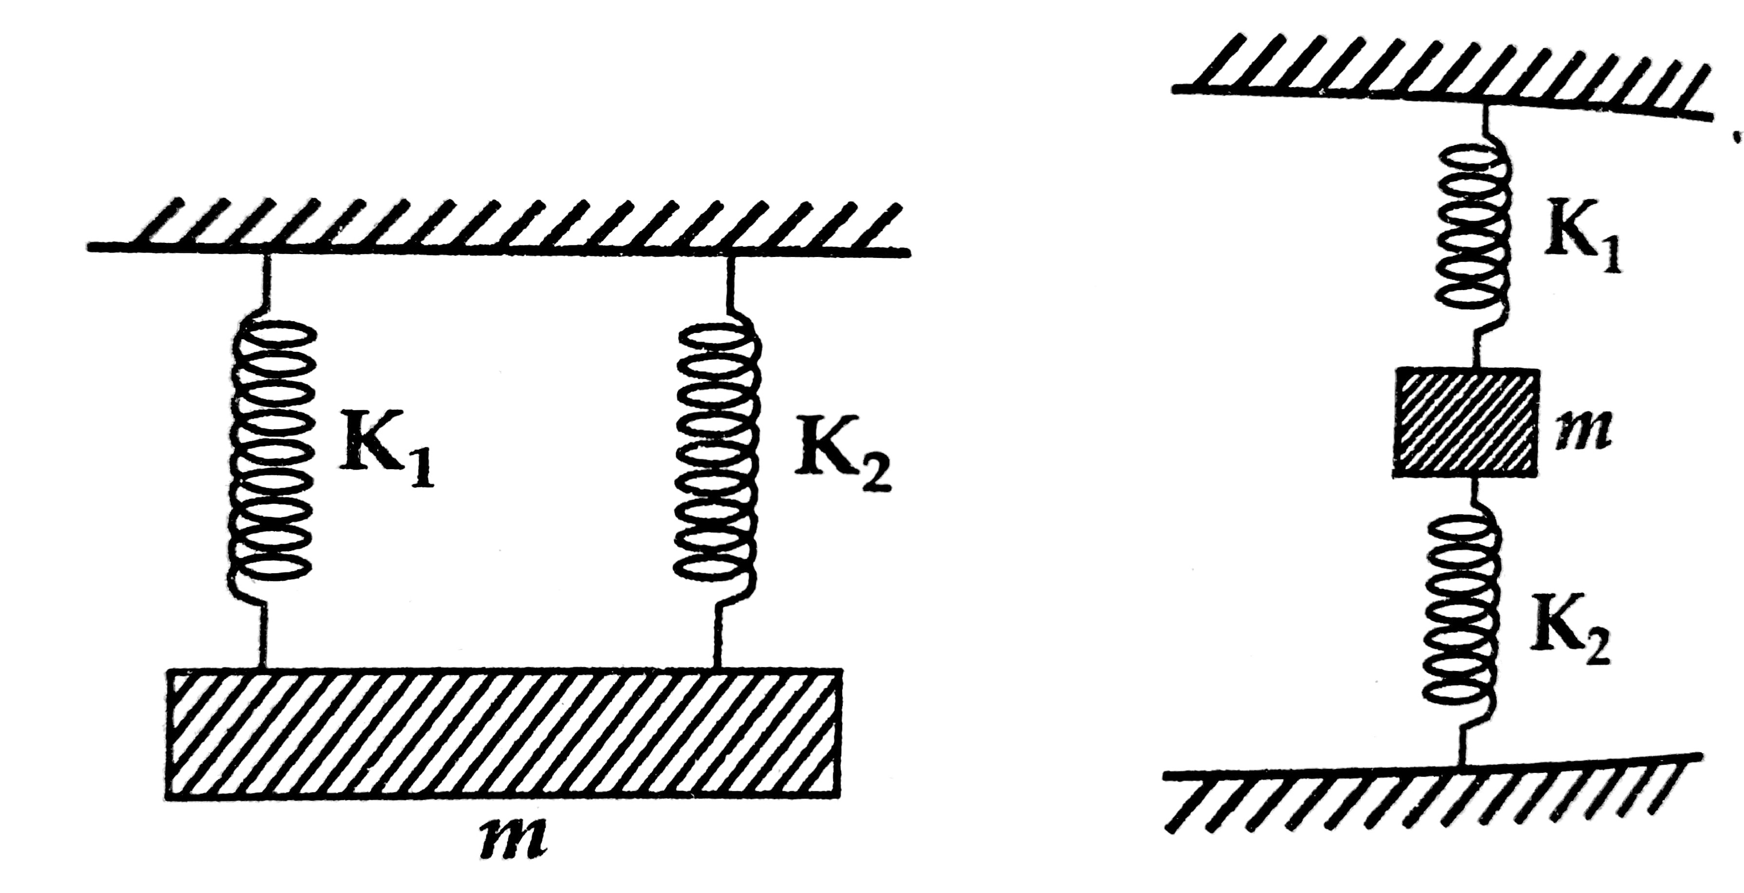
Here is a visual interpretation of springs in a parallel combination If the Force Constant of two springs in series combination is K_{p}

And the oscillation Period would be

